Activity: Web Site Selection
- The name and URL of the website selected for critique
XDA Portal & Forums - https://www.xda-developers.com/
- A screen image of the landing page of the web site
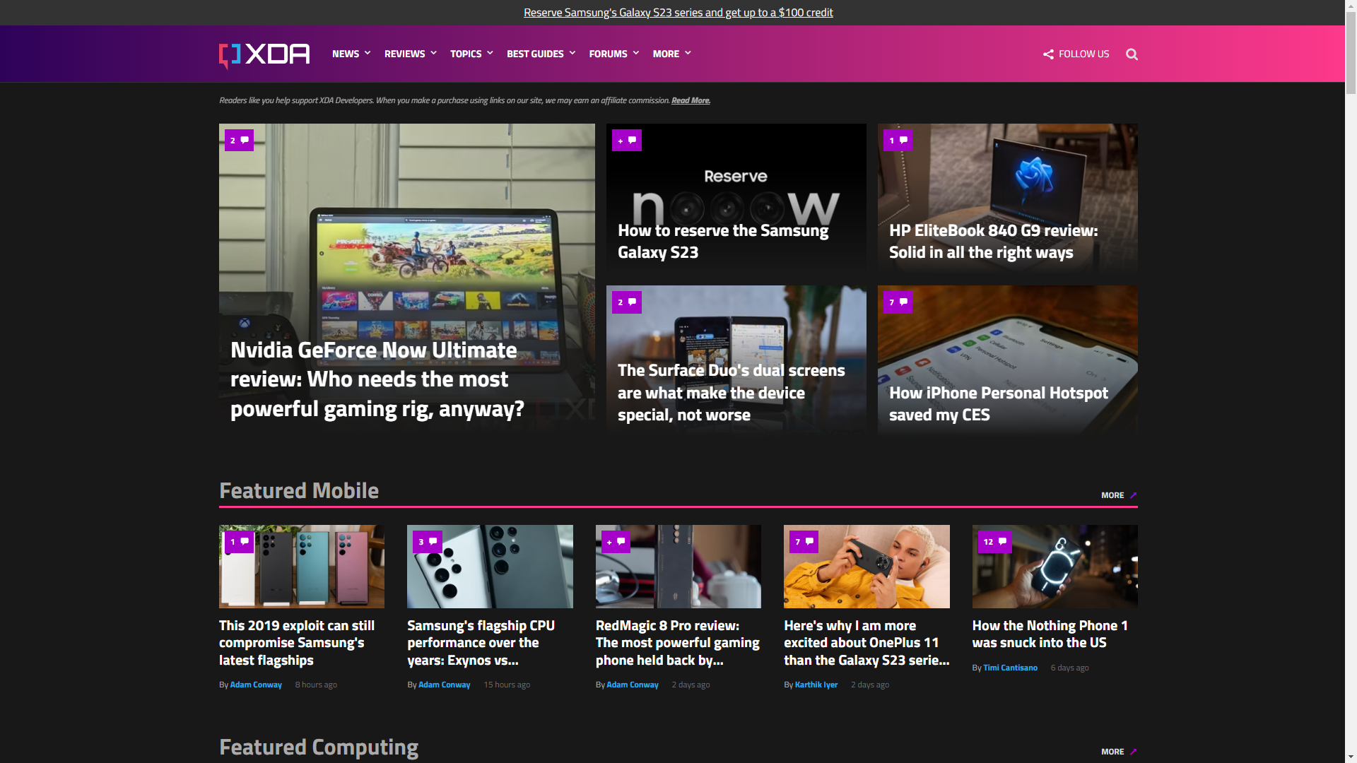
- An overview of the purpose of the web site: include a description of the tasks that a user can perform using your selected web site. Include screen shots to illustrate the tasks or draw on top of the landing page to annotate the different tasks.
- Latest news about mobile devices and also review blog of mobile devices by xda writers & technical editors
- Navigation for mobile news/reviews, computing news/reviews, deals, and topics for Andriod, Apple, Chrome, Windows and development.
- Access to forums where there are tools and guides for specific mobile devices and other technologies (like firetv, roku, and etc…)
News and Review on Mobile Device | Forum Site (Guide and Tools) for Mobile Devices
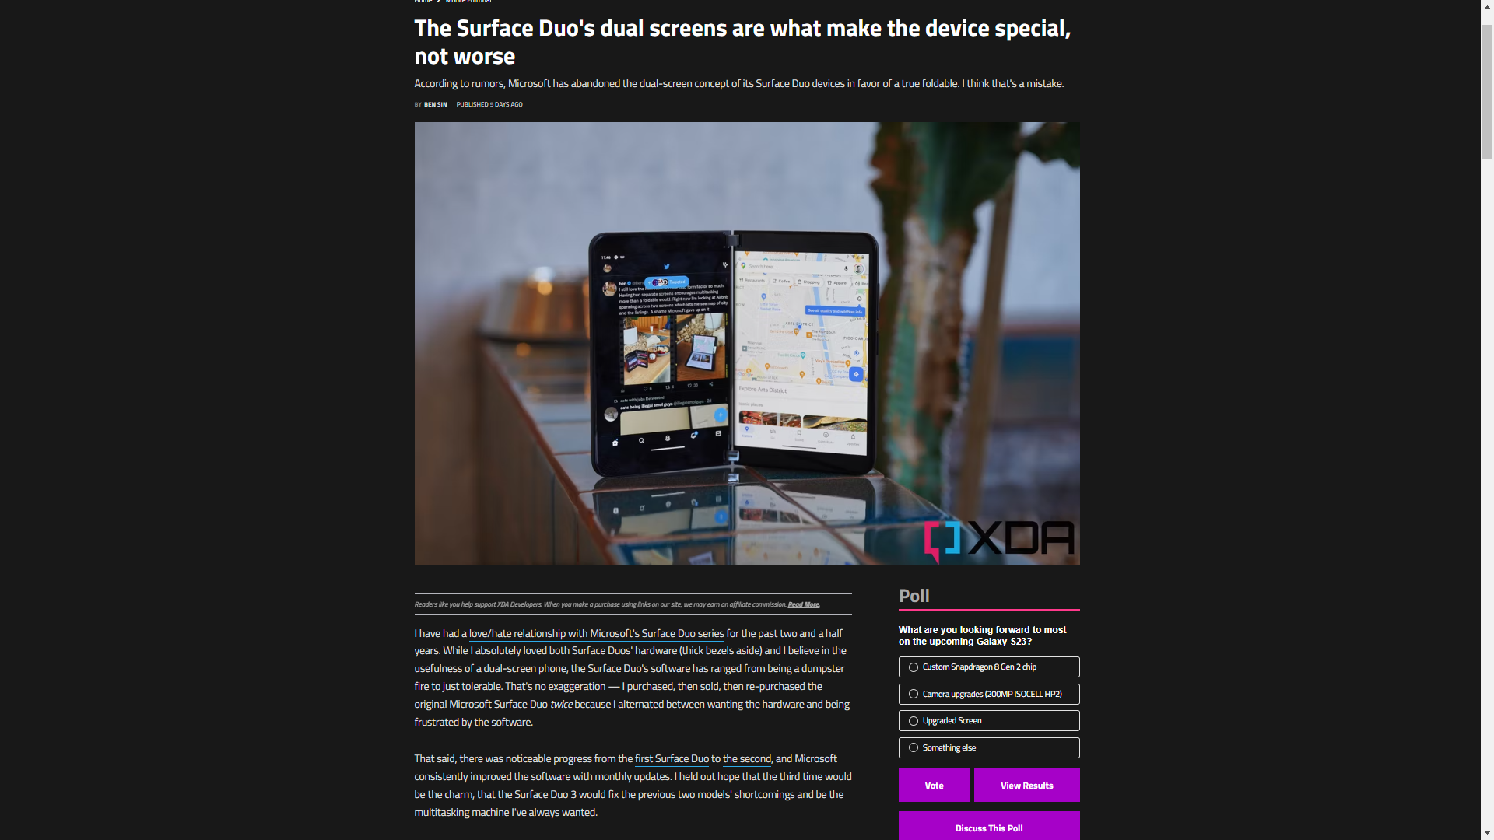 | 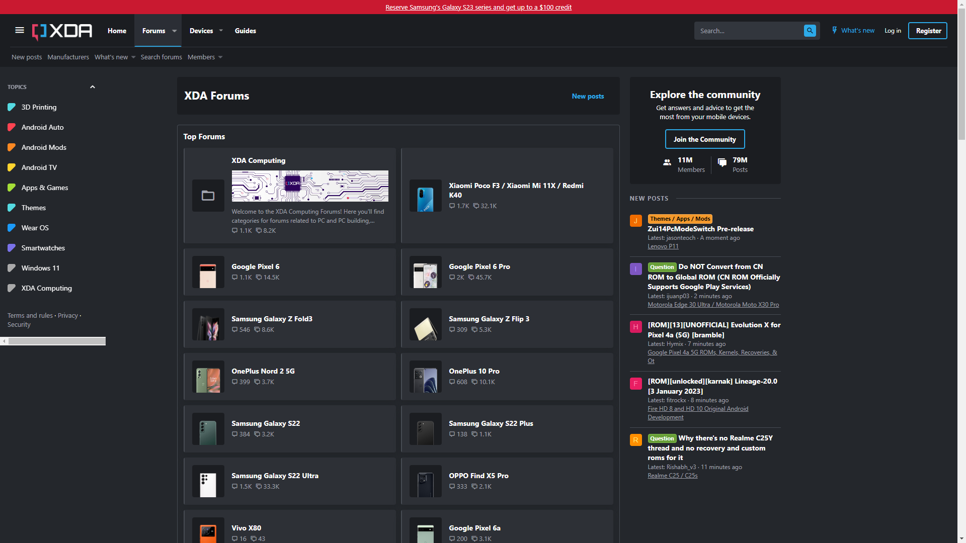
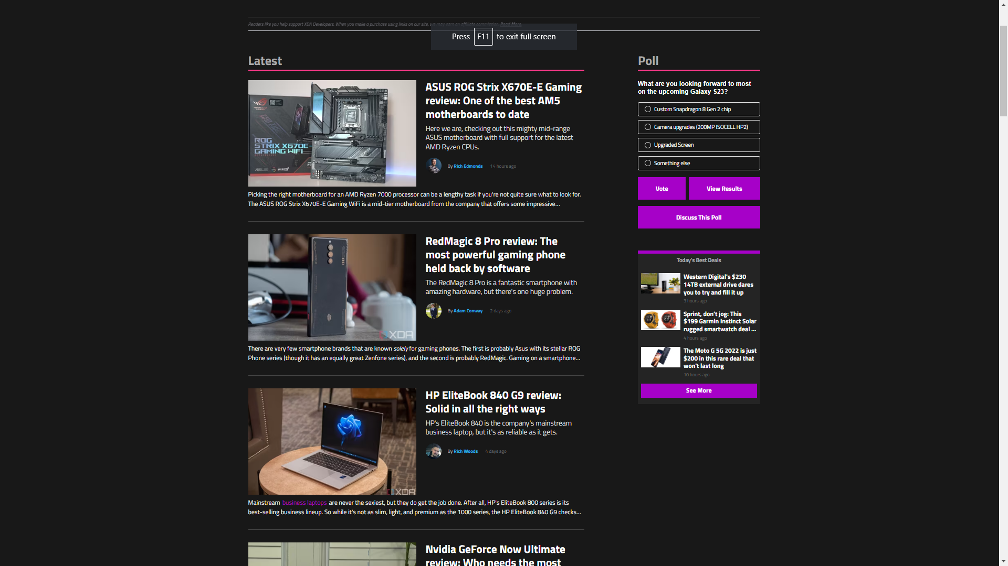 | 